Level measurement: WIKA
extends its portfolio for the OEM market

Klingenberg, February 2017.
WIKA has extended its portfolio for industrial level measurement with new level sensors, float switches and optoelectronic switches.

Together with the existing submersible pressure sensors and a programmable level switch with display, one of the widest offerings in this market is thus available to OEM customers. The selection of sensors with hydrostatic and reed-chain measurement technology and of magnetic and optoelectronic level switches enables product solutions for all typical OEM measuring tasks. A modular concept ensures that the instruments are only equipped with the features actually needed. This therefore enables a very good price/performance ratio.

The production process has been optimised for the demands of OEM customers. Instruments in high lot sizes can also be delivered in a short period of time.

Number of characters: 820
Key words: OEM level measurement

Manufacturer:
WIKA Alexander Wiegand SE & Co. KG
Alexander-Wiegand-Straße 30
63911 Klingenberg/Germany
Tel. +49 9372 132-0
Fax +49 9372 132-406
vertrieb@wika.com
www.wika.de

WIKA company photograph:
WIKA has extended its portfolio for industrial level measurement

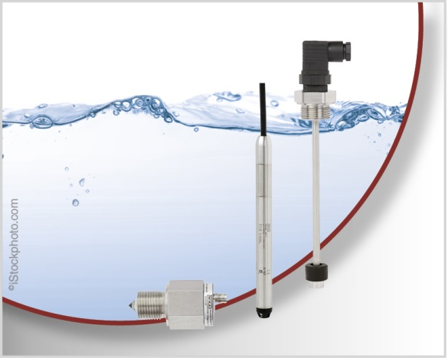

Edited by:
WIKA Alexander Wiegand SE & Co. KG
André Habel Nunes
Marketing Services
Alexander-Wiegand-Straße 30
63911 Klingenberg/Germany
Tel. +49 9372 132-8010
Fax +49 9372 132-8008010
andre.habel-nunes@wika.com
www.wika.de

WIKA press release 03/2017

